Log Analysis & Alerting Tool for a Retail Chain
OBJECTIVE: Your group is building a working prototype/deliverable for "Log Analysis & Alerting Tool for a Retail Chain" — a realistic, portfolio-quality project modeled on real client work, not a textbook exercise.

Prepared By: Sarrah Amini

Mini-Plan
As Member 1, I focused on implementing the log analysis and alerting component of the project using Wazuh SIEM. My plan was to:
- Set up Wazuh as the centralized security monitoring platform and connect the Kali Linux endpoint as an agent.
- Generate controlled security events on the Kali endpoint to test Wazuh's detection capabilities.
- Analyze the generated alerts and document the relevant rule information and security significance.
- Document recommended incident-response steps for each detected alert and compile the results into a log-review report.

Detection 1: Failed SSH Authentication
Detection Type: Failed SSH login / authentication failure
Objective: Detect unsuccessful SSH authentication attempts against a monitored Linux endpoint.
Security Scenario: An attacker may attempt to gain unauthorized access to a Linux system through SSH by trying different usernames and passwords. An attempt to authenticate using a non-existent username can be an indicator of reconnaissance, unauthorized access attempts, or the early stage of an SSH brute-force attack.
Environment:
- SIEM: Wazuh
- Monitored endpoint: Kali-Lab
- Operating system: Kali Linux
- Wazuh Manager: 192.168.100.232
Detection Method: Wazuh's built-in SSH authentication detection was used to identify an attempt to log in using a username that does not exist on the monitored system.
Test Procedure: A failed SSH authentication attempt was intentionally generated on the monitored Kali endpoint using:
ssh wronguser@localhost
An invalid password was entered to generate an authentication failure event.
Endpoint Evidence: The failed authentication event was recorded in:
/var/log/auth.log
Detection Results:
Rule ID: 5710
Rule Level: 5
Rule Description: sshd: Attempt to login using a non-existent user
Rule Groups:
- syslog
- sshd
- authentication_failed
- invalid_login
MITRE ATT&CK Techniques shown by Wazuh:
- T1110.001 — Password Guessing
- T1021.004 — SSH
Agent: Kali-Lab
Detection Result: The failed SSH authentication event was successfully collected by the Wazuh agent and detected by Wazuh's built-in detection rules. The resulting alert was displayed in the Wazuh Dashboard.
Recommended Incident Response:
- Verify whether the failed login was legitimate.
- Review the source IP address of the authentication attempts.
- Check whether multiple failures occurred within a short period.
- If brute-force activity is suspected, investigate the source IP.
- Review successful logins following the failed attempts.
- Consider restricting SSH access and enforcing stronger authentication controls.
Screenshots:
- Screenshot 1.1 — Failed SSH authentication on Kali
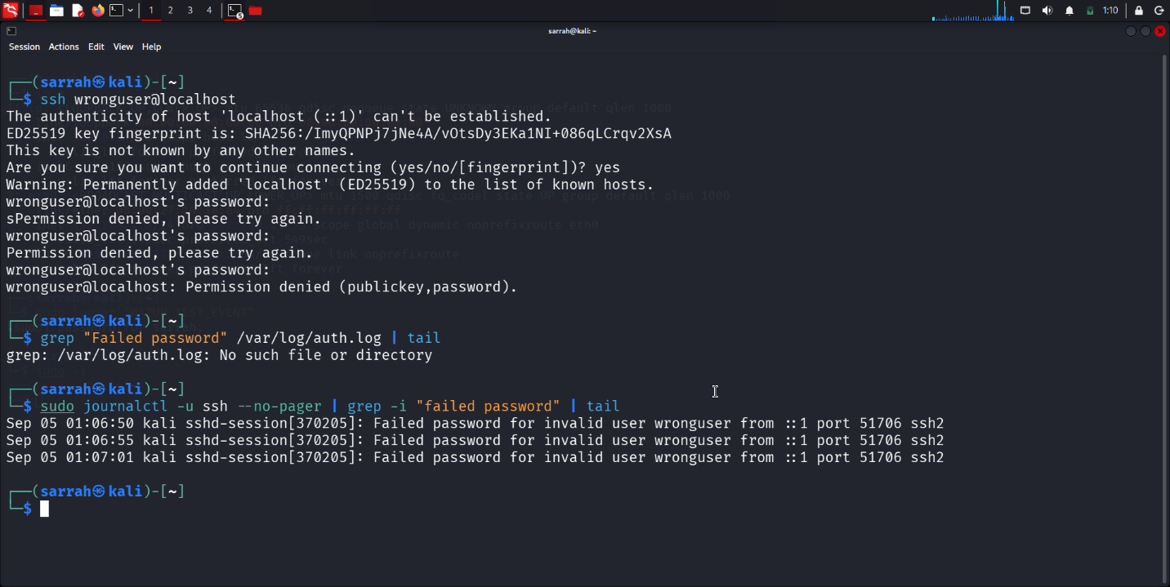
- Screenshot 1.2 — Wazuh alert showing the detected event and rule information
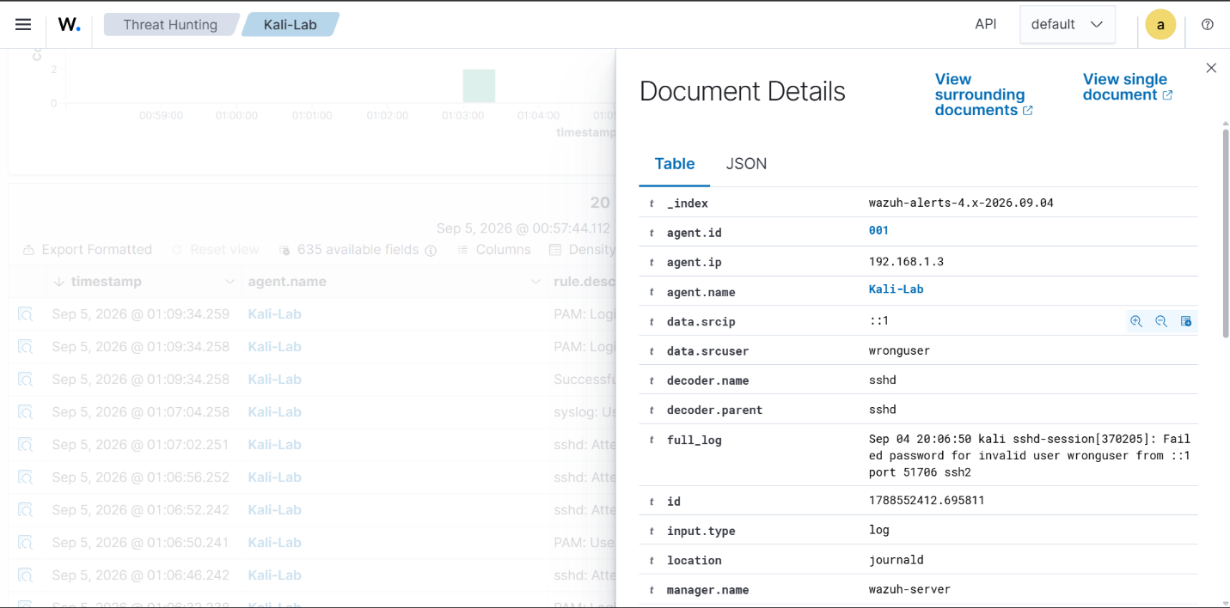
Screenshot 1.3:
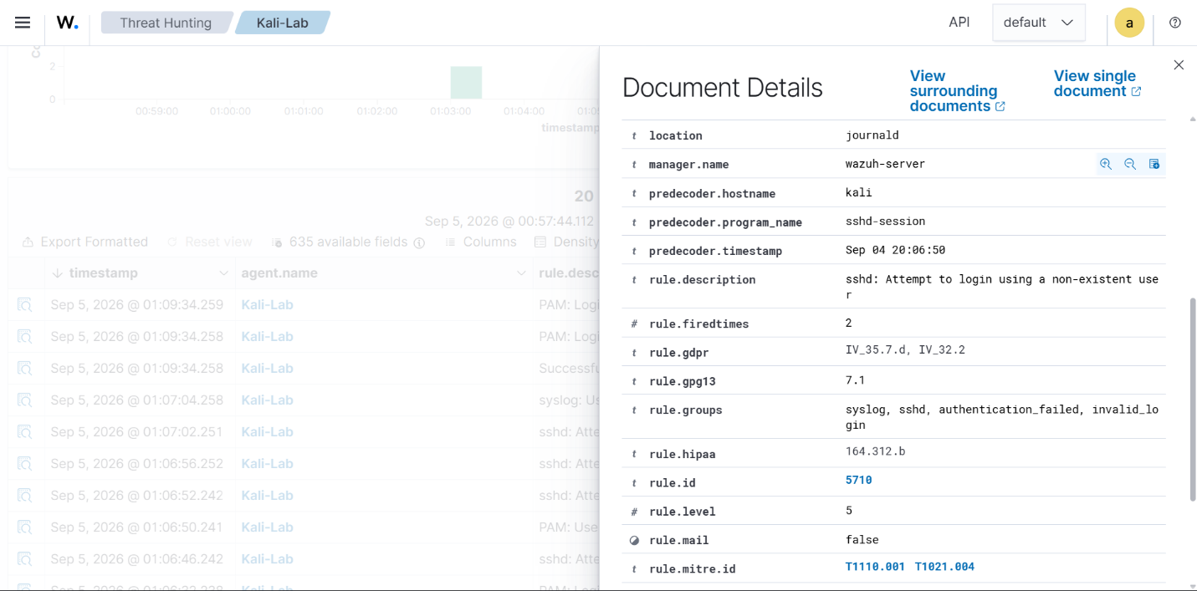

Detection 2: New Local User Account Creation
Detection Type: User account modification / system configuration change
Objective: To detect activity associated with the creation of a new local user account on a monitored Linux endpoint.
Security Scenario: An attacker who gains unauthorized access to a Linux system may create a new local user account to maintain persistence, gain access to the system at a later time, or obtain additional privileges.
Environment:
- SIEM: Wazuh
- Monitored endpoint: Kali-Lab
- Operating system: Kali Linux
- Wazuh Manager: 192.168.100.232
Test Procedure: A controlled test was performed on the monitored Kali Linux endpoint by creating a new local user account.
The following command was executed:
useradd -m wazuh_testuser
The account creation was then verified using:
id wazuh_testuser
The account's presence in the local user database was also verified using:
grep "wazuh_testuser" /etc/passwd
These commands confirmed that the test account had successfully been created on the monitored endpoint.
Wazuh Detection: The Wazuh agent on Kali-Lab collected the resulting system activity and forwarded the event to the Wazuh manager.
The event was then analyzed by Wazuh's built-in detection capabilities and displayed in the Wazuh Dashboard.
Wazuh Alert Details:
Agent: Kali-Lab
Rule ID: 5902
Rule Level: 8
Rule Description: New user added to the system.
Rule Groups:
- Syslog
- adduser
MITRE ATT&CK:
- T1136 -- Create Account
Detection Result: The controlled creation of a new local user account generated system activity on the Kali-Lab endpoint. Wazuh successfully collected and analyzed the resulting event and generated a corresponding security event in the Wazuh Dashboard.
This demonstrates Wazuh's ability to monitor endpoint activity that may be associated with unauthorized account creation.
Security Significance: Unexpected creation of a local account can be an indicator of compromise.
In a retail environment, an attacker who compromises a Linux server could potentially create an additional account and use it to maintain access even after the original attack vector is closed.
Therefore, account-creation events should be reviewed to determine whether the activity was:
- Authorized administrative activity
- A legitimate software/system operation
- An unauthorized account creation
- Part of a larger compromise
Recommended Incident Response:
1. Validate the account. Determine whether the newly created account was expected and authorized.
2. Identify the account's privileges. Check its groups and permissions. For example: id <username>
3. Investigate related activity. Review events around the same timestamp for:
- Successful logins
- Failed logins
- Privilege escalation
- Suspicious commands
- Changes to important system files
4. Disable unauthorized accounts. If the account is confirmed to be unauthorized, disable or remove it according to the organization's incident-response procedure.
5. Investigate the source of the activity. Determine which user/process/session created the account and whether the endpoint may have been compromised.
6. Continue monitoring. Monitor the endpoint for additional suspicious activity or attempts to create additional accounts.

Screenshot:
Screenshot 2.1 — Account Creation
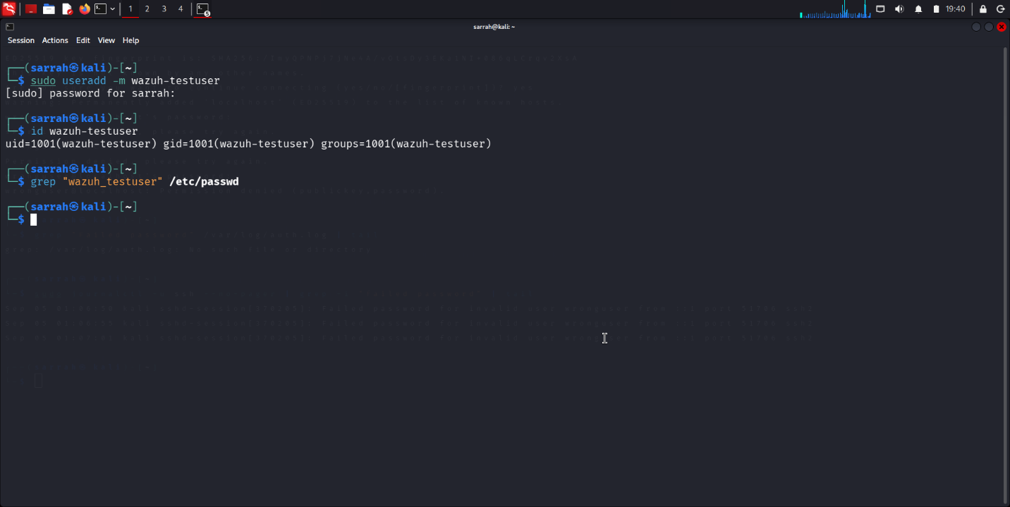
Screenshot 2.2 — Wazuh Alert
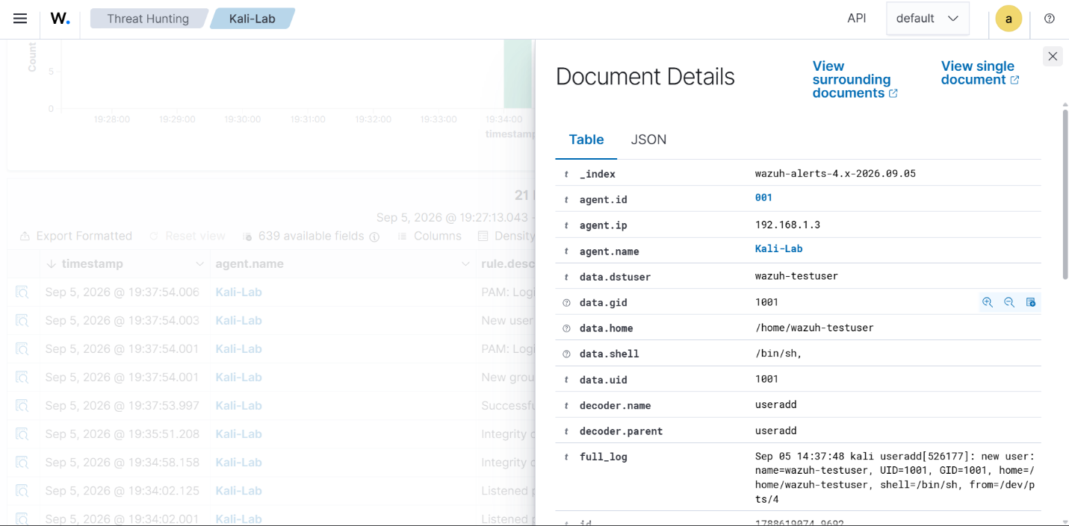
Screenshot 2.3:
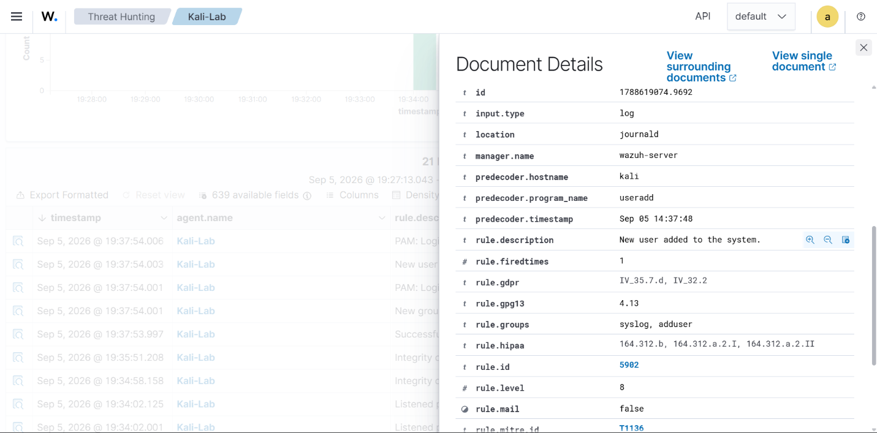

Detection 3: Unauthorized File Modification
Detection Type: File Integrity Monitoring (FIM)
Objective: To detect unauthorized changes to files located within monitored directories on a Linux endpoint.
Security Scenario: An attacker who gains unauthorized access to a system may modify existing files or add new files in order to alter system behavior, establish persistence, or tamper with important system resources. File Integrity Monitoring helps identify such changes by monitoring specified files and directories for modifications.
Environment:
- SIEM: Wazuh
- Monitored endpoint: Kali-Lab
- Operating system: Kali Linux
- Wazuh Manager: 192.168.100.232
Test Procedure: A controlled file-creation event was generated on the monitored Kali Linux endpoint.
The following command was executed:
sudo touch /etc/wazuh_test_file.txt
The test file was created inside the /etc directory.
The file was then verified using:
ls -l /etc/wazuh_test_file.txt
The /etc directory was selected because it is included in the Wazuh agent's File Integrity Monitoring configuration.
Wazuh's syscheck component monitored the directory and detected the resulting file-system change.
Wazuh Detection: The Wazuh agent on Kali-Lab detected the file-system change through its File Integrity Monitoring functionality and forwarded the event to the Wazuh manager.
The event was analyzed using Wazuh's built-in detection rules and displayed in the Wazuh Dashboard.
Wazuh Alert Details
Agent: Kali-Lab
Rule ID: 5402
Rule Level: 3
Rule Description: Successful sudo to ROOT executed.
Detection Component: syscheck
File: /etc/wazuh_test_file.txt
Detection Result: The creation of a test file within the monitored /etc directory was successfully detected by Wazuh's File Integrity Monitoring component. The resulting syscheck event was displayed in the Wazuh Dashboard and provided information about the affected file and the detected file-system change.
This demonstrates Wazuh's ability to monitor protected system directories and identify unauthorized file activity.
Security Significance: Unexpected modifications or additions to system files can be an indicator of malicious activity. In a retail environment, unauthorized changes to files on servers supporting business applications could potentially affect system functionality, security configurations, or application behavior.
File Integrity Monitoring allows security teams to identify these changes and investigate them before they develop into a larger security incident.
Recommended Incident Response:
1. Verify the file change. Determine whether the file was created or modified as part of an authorized administrative or software activity.
2. Identify the affected file. Review the file path and determine whether the affected file is a critical system or application file.
3. Investigate related activity. Review other security events occurring around the same timestamp, including:
- User authentication
- Privileged commands
- Process execution
- Additional file modifications
- Other suspicious activity
4. Check file contents. If the file is unauthorized, examine its contents and determine whether it contains malicious or suspicious information.
5. Remove or restore the unauthorized change. If confirmed to be malicious or unauthorized, remove the file or restore the affected file from a trusted source according to the organization's incident-response procedure.
6. Investigate possible compromise. Determine how the unauthorized change occurred and whether other files or systems may have been affected.
7. Continue monitoring. Continue monitoring the endpoint for additional file modifications or other indicators of compromise.
Screenshot:
Screenshot 3.1 — File Creation
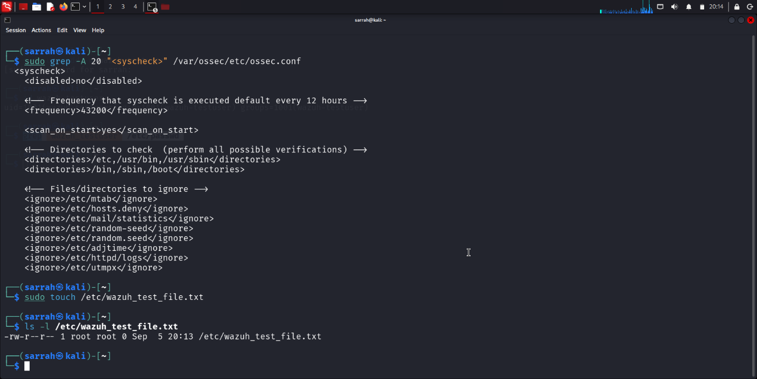
Screenshot 3.2 — Wazuh FIM Alert
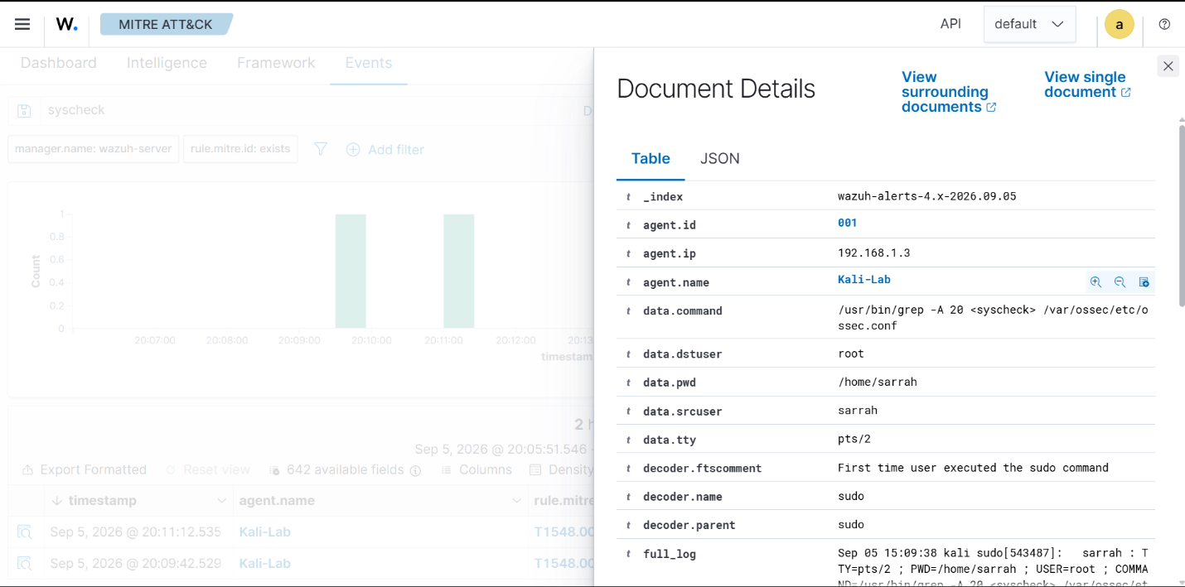
Screenshot 3.3:
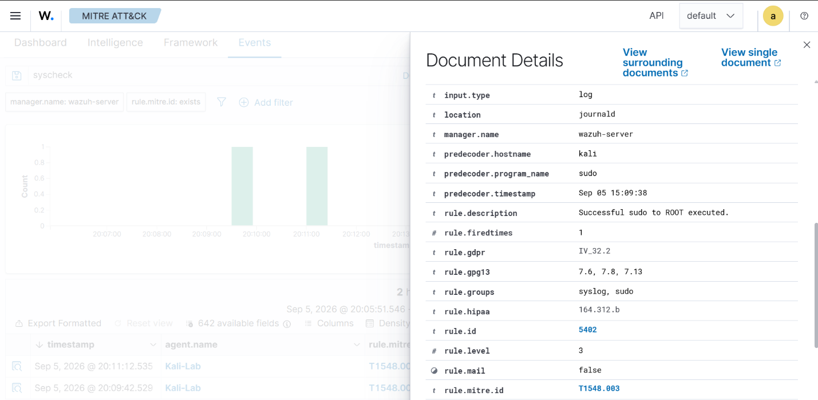

Detection 4: Privileged Command Execution Using Sudo
Detection Type: Privileged command / sudo activity
Objective: To detect the successful execution of a command with elevated privileges through sudo on a monitored Linux endpoint.
Security Scenario: An attacker who gains access to a user account may attempt to execute commands with elevated privileges in order to access protected resources, modify system configurations, or perform other administrative actions. Monitoring sudo activity can help identify potentially unauthorized use of elevated privileges.
2. Environment
- SIEM: Wazuh
- Monitored endpoint: Kali-Lab
- Operating system: Kali Linux
- Wazuh manager: 192.168.100.232
Test Procedure: A controlled privileged command was executed on the monitored Kali Linux endpoint using sudo.
The following command was executed:
sudo grep "sudo" /var/log/auth.log
The command was executed with elevated privileges, allowing access to the system authentication log.
The command execution generated a sudo event that was collected by the Wazuh agent and forwarded to the Wazuh manager for analysis.
Wazuh Detection: Wazuh successfully detected the privileged command execution using its built-in sudo detection capability.
The resulting event was displayed in the Wazuh Dashboard.
Wazuh Alert Details
Agent: Kali-Lab
Rule ID: 5402
Rule Level: 3
Rule Description: successfull sudo to root executed
Decoder: sudo
Command: /usr/bin/grep sudo /var/log/auth.log
Destination User: root
Rule Groups:
- syslog
- sudo
MITRE ATT&CK Technique: T1548.003 — Sudo and Sudo Caching
Detection Result: The privileged command executed through sudo was successfully collected by the Wazuh agent and detected by Wazuh's built-in rule. Wazuh generated a Level 3 alert with Rule ID 5402, identifying the successful execution of a command with elevated privileges.
The alert was displayed in the Wazuh Dashboard with information about the source user, destination user, and executed command.
Security Significance: Successful use of sudo is not inherently malicious because legitimate administrators frequently require elevated privileges. However, unexpected or unauthorized use of sudo can be an important security indicator. An attacker who compromises a standard user account may attempt to abuse available sudo privileges to execute commands as root.
In a retail environment, unauthorized privilege use could allow an attacker to modify system configurations, access sensitive information, disable security controls, or affect business-critical services.
Therefore, privileged command activity should be reviewed in its operational context.
Recommended Incident Response: If this alert occurred on an actual retail organization's system:
1. Verify the user. Determine whether the source user who executed the sudo command is authorized to perform administrative actions.
2. Review the command. Examine the command that was executed and determine whether it was appropriate for the user's role.
3. Check the user's privileges. Review the user's sudo permissions and determine whether they have excessive administrative privileges.
4. Investigate surrounding activity. Review events before and after the alert for:
- Authentication activity
- Failed login attempts
- Additional sudo commands
- Suspicious processes
- File modifications
- Other privilege-related activity
5. Restrict unauthorized access. If the activity is confirmed to be unauthorized, restrict the affected account and review its credentials and privileges.
6. Investigate potential compromise. Determine whether the account was compromised and whether the attacker performed additional privileged actions.
7. Continue monitoring. Monitor the endpoint for further unauthorized sudo or other privileged activity.
Screenshot:
Screenshot 4.1 — Privileged Command Execution
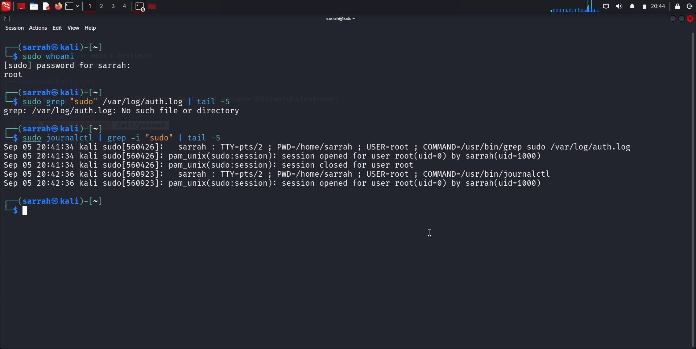
Screenshot 4.2 — Wazuh Alert
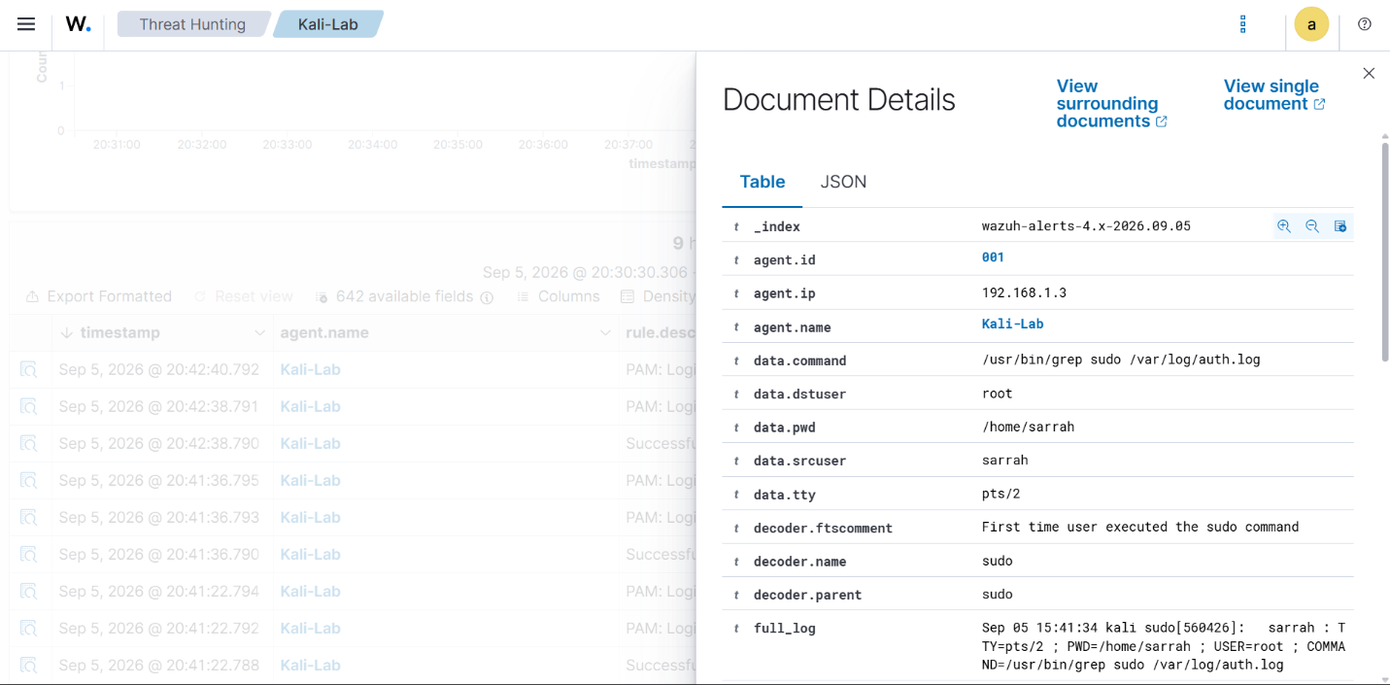
Screenshot 4.3:
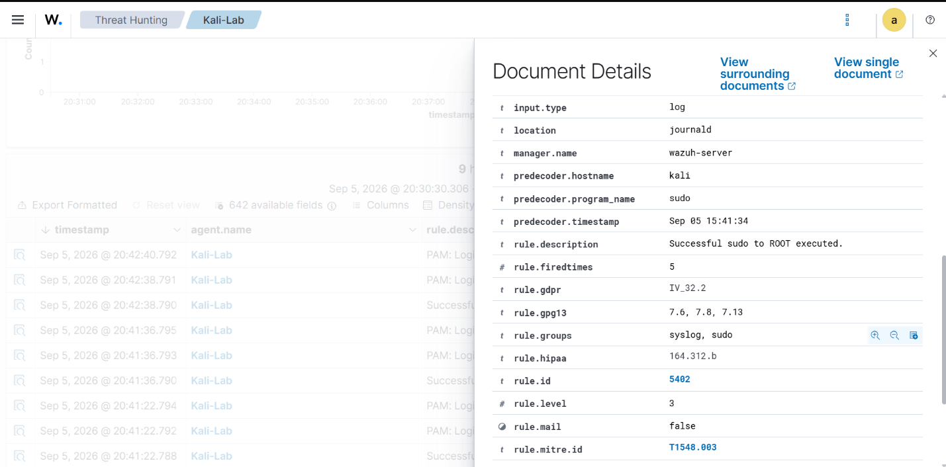

Detection 5: Suspicious Filesystem Search Using find
Detection Type: Suspicious Filesystem Search Using find
Objective: Detect the execution of a filesystem search command with elevated privileges, which may be used by an attacker to locate sensitive system files.
The find command was executed with sudo privileges to search the filesystem for a file named passwd. Wazuh successfully captured the command execution and generated an alert for successful sudo activity.
2. Environment
- SIEM: Wazuh
- Monitored endpoint: Kali-Lab
- Operating System: Kali Linux
- Wazuh manager: 192.168.100.232
Test Procedure: The following command was executed on the Kali Linux endpoint:
sudo find / -name passwd
This command searches the filesystem starting from / for files named passwd.
The command was intentionally executed in the controlled lab environment to generate a security monitoring event.
Wazuh Detection: Wazuh successfully detected the command execution through the sudo decoder.
/usr/bin/find / -name passwd
The event showed that the command was executed with elevated privileges.
Detection Result:
- Agent: Kali Lab
- Rule ID: 5402
- Rule level: 3
- Rule groups: syslog, sudo
Detection Result: The test was successful. Wazuh detected the privileged execution of the find command and generated an alert under its successful sudo rule.
Security Significance: Filesystem searches can be part of legitimate administrative activity, but attackers may also use commands such as find to locate sensitive files after gaining access to a system. For example, searching for files such as passwd, configuration files, credentials, keys, or application data can assist an attacker during system reconnaissance. The use of sudo is particularly important because it indicates that the command was executed with elevated privileges.
The alert is therefore useful for monitoring privileged command execution and investigating potentially suspicious administrative activity.
Recommended Incident Response: If this alert occurs in a real environment:
- Verify the user who executed the command.
- Review the command and determine whether it has a legitimate administrative purpose.
- Check the user's sudo privileges and confirm that elevated access is authorized.
- Review surrounding events for other suspicious commands or authentication activity.
- Investigate additional filesystem access if the activity appears unauthorized.
- Restrict or disable unauthorized privileged access where necessary.
- Continue monitoring the endpoint for additional suspicious activity.
Screenshot:
Screenshot 5.1:
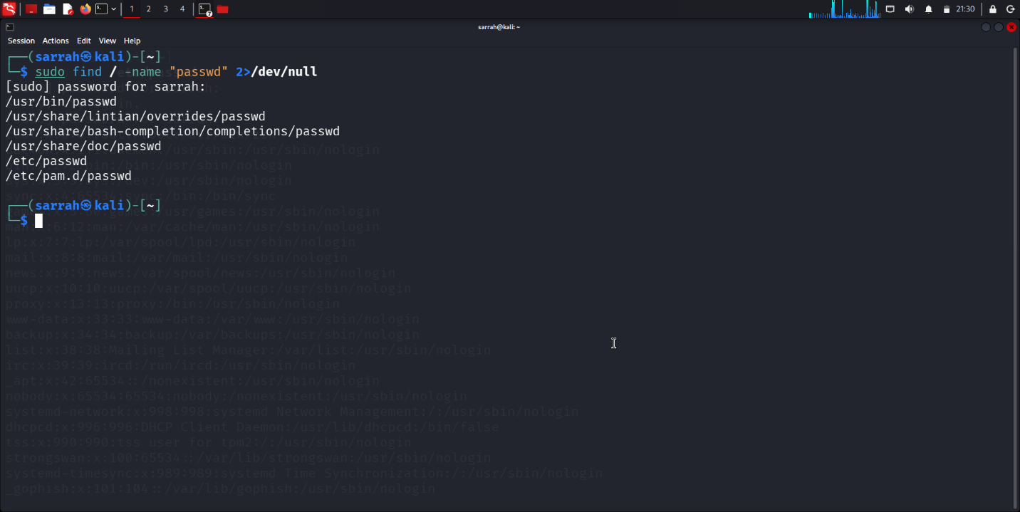
Screenshot 5.2: Wazuh detection
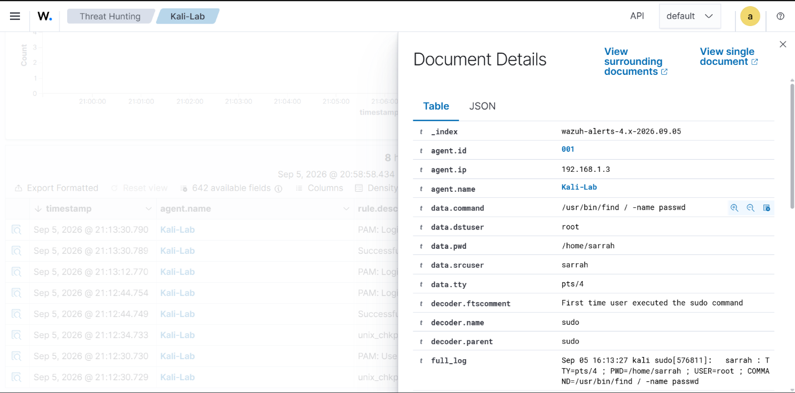
Screenshot 5.3:
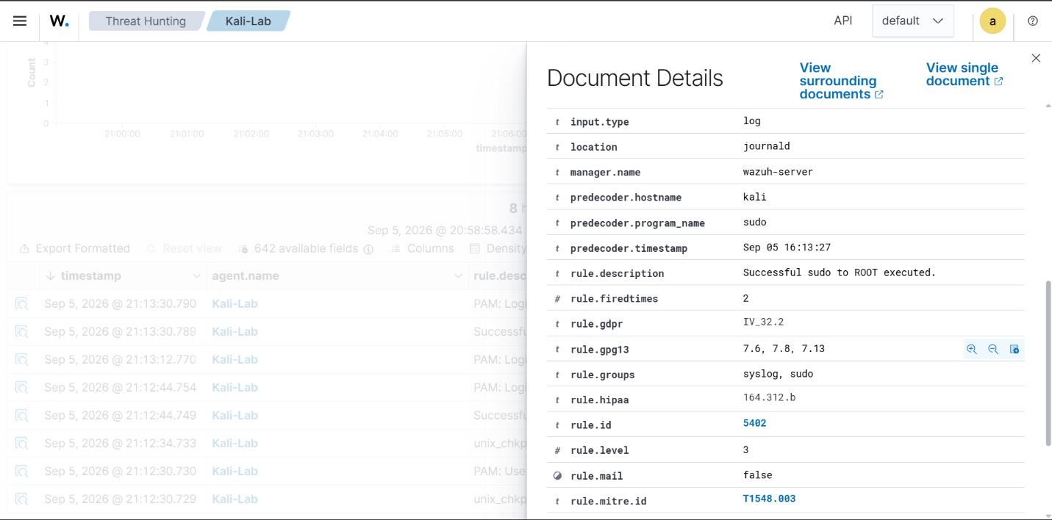

Overall Findings / Incident Response
The detection tests demonstrated that Wazuh can provide centralized visibility into security-related activity occurring on a monitored endpoint. The Kali Linux agent generated controlled security events, which were collected by Wazuh and evaluated using its detection rules.
The five detection scenarios covered different types of security-relevant activity, including failed authentication attempts, local user account creation, file integrity changes, privileged command execution using sudo, and filesystem search activity. Each event was reviewed through the Wazuh Dashboard to identify the corresponding rule information, affected user, command or activity, rule level, and MITRE ATT&CK mapping where available.
The tests showed how Wazuh can assist a security team in identifying potentially suspicious behavior and investigating events from a centralized monitoring platform. The alerts provide useful information that can be used to determine whether an activity is legitimate or requires further investigation.
General Incident Response Workflow
For any suspicious alert detected by Wazuh, the following response workflow can be followed:
- Validate the Alert: Review the alert details and determine whether the detected activity was authorized or suspicious.
- Identify the Source: Check the affected agent, username, command, process, and other available event information.
- Investigate Related Activity: Review surrounding logs and alerts to identify any additional suspicious actions.
- Assess the Impact: Determine whether the activity could indicate unauthorized access, privilege abuse, persistence, or system modification.
- Contain the Threat: If unauthorized activity is confirmed, restrict the affected account, process, or access method as appropriate.
- Remediate the Issue: Remove unauthorized accounts or files, correct permissions, and address the underlying security weakness.
- Monitor the Endpoint: Continue monitoring the affected system for additional suspicious activity.
- Document the Incident: Record the alert, investigation findings, actions taken, and final outcome for future reference.
Overall, the detection exercises demonstrate the basic workflow of a SIEM-based security monitoring solution: endpoint activity is generated, collected by Wazuh, analyzed using detection rules, presented as alerts, and then investigated through an incident-response process.

Conclusion
The Log Analysis & Alerting Tool for a Retail Chain was successfully implemented as a security monitoring prototype using Wazuh SIEM. A Kali Linux endpoint was connected to the Wazuh manager to generate and monitor security-related events.
Five detection scenarios were tested and documented, covering authentication failures, local user account activity, file integrity monitoring, privileged command execution, and filesystem search activity. Each test demonstrated how Wazuh collects endpoint events, applies detection rules, generates security alerts, and provides relevant information for investigation.
The project also included recommended incident response steps for each detected alert. These steps provide a basic workflow for validating suspicious activity, investigating related events, reviewing user privileges, and taking appropriate containment and remediation actions.
Overall, the project demonstrates how Wazuh can be used as a centralized security monitoring and alerting solution to improve visibility into endpoint activity and assist security teams in identifying and responding to potentially suspicious behavior in a controlled environment.

